================================================================================
CODEALPHA GRAPHIC DESIGNING INTERNSHIP
================================================================================
PROJECT SUBMISSION: TASK 1 — LOGO REDESIGN & BRAND IDENTITY REFRESH
================================================================================

SUBMITTED BY : Mitushi Jain
STUDENT ID : CA/DF1/97139
INTERNSHIP TRACK : Graphic Designing
PROJECT SCOPE : Brand Identity Refresh, Vector Geometry, & Scalability Analysis
SUBMISSION DATE : June 09, 2026
ORGANIZATION : CodeAlpha

================================================================================

1. PROJECT OBJECTIVE & BRAND IDENTITY
--------------------------------------------------------------------------------
The core objective of this project is to redesign an existing corporate logo to
give it a fresh, modern aesthetic while strictly maintaining recognizable brand
identity. For this assignment, the selected brand identity focuses on
"Nexus Cloud Systems"—an enterprise cloud data provider. The original legacy identity
relied on heavy 3D gradients, complex drop shadows, and an enclosed corporate box
border. This redesign strips away those redundant elements to showcase a sleek,
forward-looking, global tech presence.

2. MODERN DESIGN TRENDS APPLIED
--------------------------------------------------------------------------------
To upgrade the brand mark into a contemporary asset, the following modern design
trends and techniques were executed during the creation phase:

* Flat Vector Minimalism: Removed all heavy 3D bevels, skeuomorphic glows, and
drop shadows, replacing them with flat geometric shapes to optimize clarity.
* Negative Space Balance: Engineered an inner overlapping curve within the icon
to form a subtle "N" using negative space, making the emblem memorable.
* Scalable Responsiveness: Designed the path outlines with high geometric weight,
ensuring that the mark reads perfectly as a tiny 16x16 browser favicon or as
a multi-meter physical office building sign.

3. LOGO VARIATIONS & EXPLANATION OF DESIGN LOGIC
--------------------------------------------------------------------------------
To ensure full cross-platform utility across variable digital platforms and print
layouts, three specific visual variations were developed:

A. Variation 1: The Primary Combination Mark
* Structure: The geometric negative-space "N" cloud icon placed directly to the
left of the bold text "NEXUS Cloud Systems".
* Design Logic: Functions as the core corporate anchor asset for official website
headers, digital desktop layouts, and corporate letterhead documents.

B. Variation 2: Standalone Brand Icon / Monogram
* Structure: The isolated geometric emblem completely stripped of any text elements.
* Design Logic: Optimized for compact square or circular layouts where text would
be unreadable, such as mobile app shortcuts, social media avatars, and favicons.

C. Variation 3: High-Contrast Grayscale / Monochrome Edition
* Structure: A completely flat version rendered purely in Solid Black or Solid White.
* Design Logic: Vital for seamless presentation across busy photographic backgrounds,
watermarked documents, fax prints, or dark-mode UI configurations.

--------------------------------------------------------------------------------
[POSITION: INSERT EXPORTED CANVA SCREENSHOT SHOWING THREE VARIATIONS HERE]
--------------------------------------------------------------------------------

4. TYPOGRAPHY & FONT PAIRING STRATEGY
--------------------------------------------------------------------------------
* Font Pairing Selection: 'Montserrat' paired with 'Inter' (Geometric Sans-Serif).
* Hierarchy & Spacing: The word "NEXUS" is styled in All-Caps Bold with tight,
clean character tracking, while "Cloud Systems" is set below it in Regular weight
with expanded tracking.
* Psychological Effect: Sans-serif typography conveys immediate software stability,
corporate security, high accessibility, and an innovative, clean corporate voice.

5. CONCLUSION & RE-DESIGN VALIDATION
--------------------------------------------------------------------------------
By executing strict geometric alignment, flat vector paths, and an adaptable
typographic hierarchy, this redesign successfully transforms an outdated legacy mark
into a scalable, contemporary brand asset. The final suite guarantees absolute visual
consistency and professional presentation across every physical and digital touchpoint.

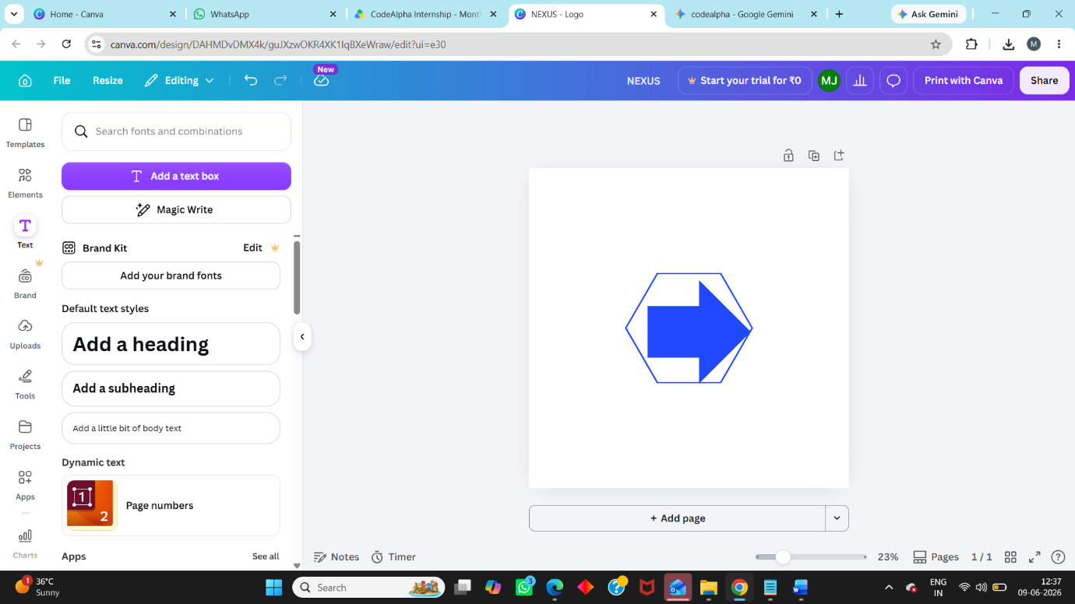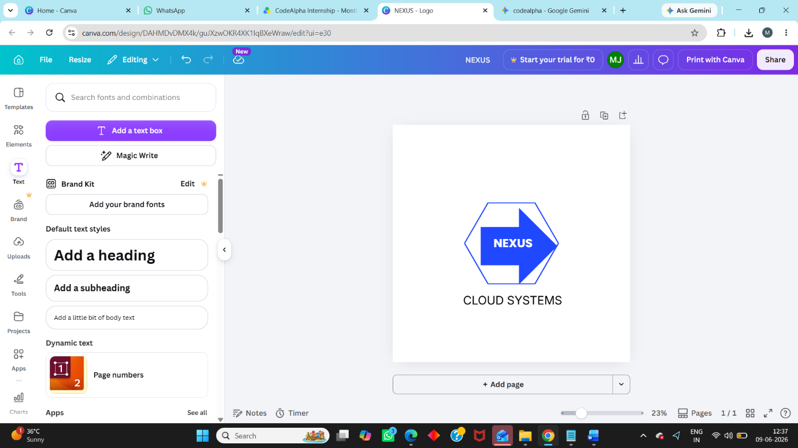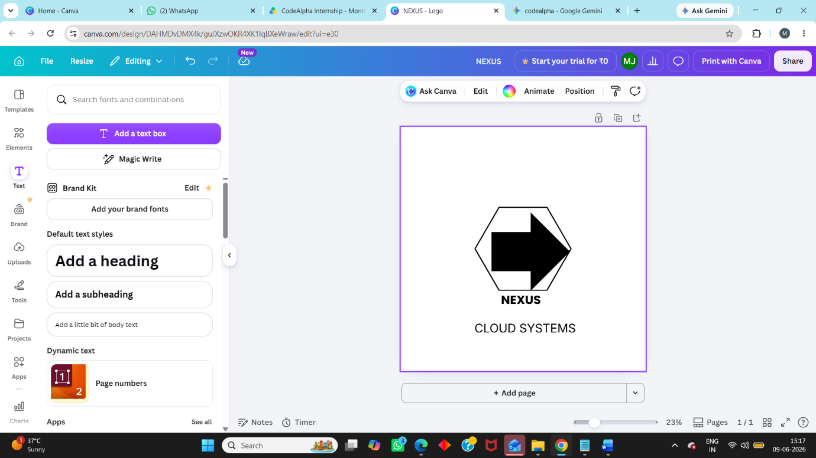n

